Session 2026-2027

Vision:Dream of where you want. | Mission: Means to achieve Vision

Program Educational Objectives of the program (PEO): (broad statements that describe the professional and career accomplishments)
PEO1 | Preparation | P: Preparation | Pep-CL abbreviation  pronounce as Pep-si-lL easy to recall
PEO2 | Core Competence | E: Environment (Learning Environment)
PEO3 | Breadth | P: Professionalism
PEO4 | Professionalism | C: Core Competence
PEO5 | Learning Environment | L: Breadth (Learning in diverse areas)

Program Outcomes (PO): (statements that describe what a student should be able to do and know by the end of a program)
Keywords of POs:
Engineering knowledge,Problem analysis, Design/development of solutions,Conduct Investigations of Complex Problems, Engineering Tool Usage, The Engineer and The World,Ethics, Individual and Collaborative Team work,Communication, Project Management and Finance, Life-Long Learning

PSO Keywords: Cutting edge technologies, Research

“I am an engineer, and I know how to apply engineering knowledge to investigate, analyse and design solutions to complex problems using tools for entire world following all ethics in a collaborative way with proper management skills throughout my life.” to contribute to the development of cutting-edge technologies and Research.

Integrity: I will adhere to the Laboratory Code of Conduct and ethics in its entirety.

Name and Signature of Student and Date
(Signature and Date in Handwritten)

Session | 2026-27 (ODD) |  | Course Name | Web Technology Lab
Semester | 3 |  | Course Code | 23CT1301
Roll No | 65 |  | Name of Student | Shubham Dnyaneshwar Umredkar
Practical Number |  | 1B
Course Outcome |  | - Understand various internet technologies.  - Design the web pages using HTML and CSS.  - Implement the XML technology to store the data.  - Develop the interactive web pages using JavaScript.
Aim |  | Study HTML tags and implement a basic web page.
Problem Definition |  | To understand commonly used HTML tags and create a simple web page using headings, paragraphs, lists, nested lists, and hyperlinks.
Theory  (100 words) |  | HTML stands for HyperText Markup Language. It is the standard markup language used to create and structure web pages. HTML uses different tags to define elements such as headings, paragraphs, links, images, lists, tables, and forms. Most HTML elements contain an opening tag, content, and a closing tag. The <html> tag represents the complete HTML document, while <head> contains information about the page and <body> contains visible content. HTML works with web browsers to display structured information. By using different HTML tags, developers can create organized, readable, and interactive web pages for users.
Procedure and Execution  (100 Words) |  | Step for Implementation:  1. Open a text editor such as VS Code, Notepad, or Sublime Text.  2. Create a new file and save it as index.html.  3. Write the basic HTML document structure using html, head, and body tags.  4. Add headings using h1 and h2 tags.  5. Insert paragraph text using the p tag.  6. Create an unordered list using ul and an ordered list using ol.  7. Add nested lists inside the main list items.  8. Use the li tag to add individual list elements.  9. Add a hyperlink using the a tag.  10. Save the HTML file and open it in a web browser to check the output.
Code:
<!DOCTYPE html>
<html>

<head>
<title>My First Web Page</title>
</head>

<body>

<h1>Welcome to My First Web Page</h1>

<p>Hello! This is my first HTML practical.</p>

<h2>Things I Am Learning</h2>

<ul>
<li>Programming
<ul>
<li>C</li>
<li>C++</li>
<li>Java</li>
</ul>
</li>

<li>Web Technology
<ul>
<li>HTML</li>
<li>CSS</li>
<li>JavaScript</li>
</ul>
</li>
</ul>

<h2>Steps to Learn HTML</h2>

<ol>
<li>Learn basic HTML tags</li>
<li>Practice different tags
<ol>
<li>Heading tag</li>
<li>Paragraph tag</li>
<li>List tag</li>
</ol>
</li>
<li>Create a simple web page</li>
</ol>

<h2>Useful Links</h2>

<p>
<a href="https://www.youtube.com">Visit YouTube</a>
</p>

<p>
<a href="https://www.wikipedia.org">Visit Wikipedia</a>
</p>

</body>

</html>
Output:
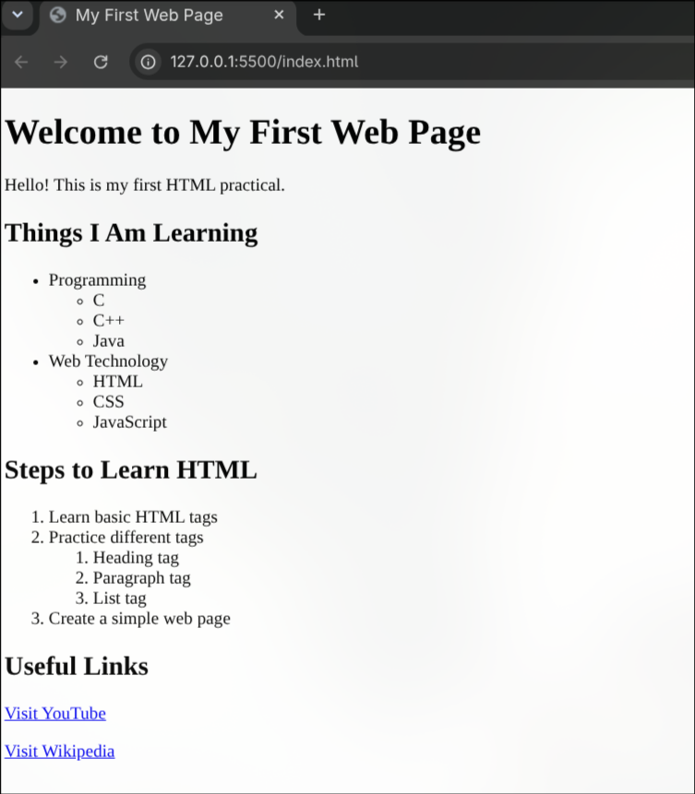
Output Analysis |  | The webpage was successfully created and displayed in the web browser. It shows headings, paragraphs, ordered lists, unordered lists, and nested lists. Two hyperlinks are also included on the webpage. The YouTube link opens the YouTube website, while the Wikipedia link opens the Wikipedia website. This practical helped in understanding the basic structure of HTML and the use of different HTML tags for creating a simple webpage.
Link of student Github profile where lab assignment has been uploaded |  | https://github.com/shubham07-codes
Conclusion |  | In this practical, I learned the basic structure of an HTML document and how different HTML tags are used to create a simple webpage. I used headings, paragraphs, ordered lists, unordered lists, nested lists, and hyperlinks. I also learned how links can be used to open websites such as YouTube and Wikipedia.
Plag Report (Similarity index < 12%)
Date |  | 07/07/2026

